Grade 7 Accelerated · Unit 3 · Lesson 4  Negative Exponent Law  Independent Set 3.04 ANSWER KEY | Name  Date  Period

Six questions, on your own, in silence. Show the step that does the work.
1. Rewrite with a positive exponent. Do not evaluate. 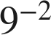


2. Find the value. 

Reciprocal of 3⁴, not −81.

3. Find the value. 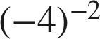

An even power of a negative base is positive.

4. Find the value. 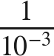
1,000
The power moves up.

5. Find the value. 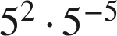
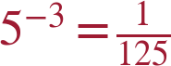
2 + (−5) = −3.

6. Find the value of . 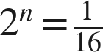
n = −4

